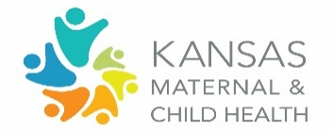
Immunizations
Women/Maternal Domain Group

Before we move through this worksheet, do you have any questions from the presentation and panel discussion that didn’t get answered?

Priority 1: Women have access to and utilize integrated, holistic, patient-centered care before, during, and after pregnancy.
Obj. 1.1: Increase the proportion of women program participants receiving a high-quality, comprehensive preventive medical visit by 5% by 2025.
What barriers and challenges have you seen in access to and uptake of immunizations for the women and maternal population and in terms of this priority, as it relates to immunizations and vaccine confidence?
Are there particular barriers or challenges you have observed related to vulnerable populations, people of color, children and youth with special health care needs, mistrust/hesitancy among certain populations, and/or equity of immunization access?
How can KMCHC better align efforts to move forward this priority and objective, as it relates to promoting immunizations and vaccine confidence? | What is one thing you and/or your organization are doing or can specifically do to move this priority and objective forward, related to promoting immunizations and vaccine confidence?

Considering the barriers and/or alignment opportunities identified, which one of these should our domain workgroup prioritize for immediate action?

